Integration Manual
SpecterX Mail Protection On-Prem Service: Configuration for Cisco SEG



Introduction
This guide will walk you through the integration of SpecterX Mail Protection Service with Microsoft Exchange Online. SpecterX enhances the security of your organization’s email communications, ensuring compliance with data protection regulations and protecting sensitive information from external threats.

With this setup, outgoing emails that are flagged or meet specific protection criteria will be routed through the SpecterX Mail Protection Server. This adds an advanced layer of security before the emails are delivered, without disrupting your current email workflow. The SpecterX Mail Protection Service integrates seamlessly into your existing email infrastructure, offering scalable protection, visibility, and control.

Additionally, we will guide you through configuring rules for explicit users and groups. This ensures that emails sent by certain users or groups are automatically protected by SpecterX, helping maintain security across key individuals and teams.

*** Remember to consult with your system administrator or IT department if you encounter any issues or if this configuration impacts other systems.

SpecterX Mail Protection Integration with Cisco Secure Email Gateway (Cisco SEG)

Step 1 - Logging In
First, we’ll log in to the Cisco Secure Email Gateway (SEG) to access the configuration settings.

- Navigate to the Cisco Secure Email Gateway (SEG) login screen.
- Enter your admin credentials to log in.
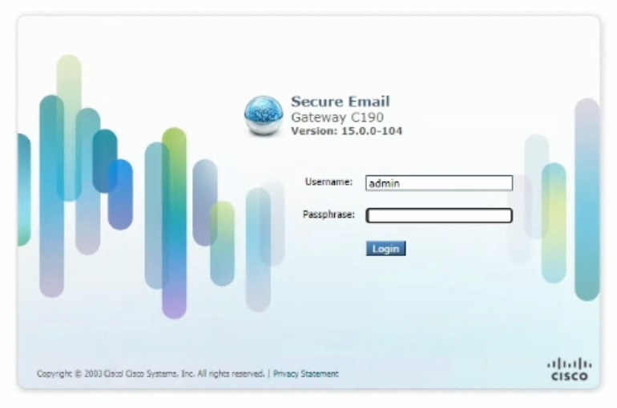

Step 2 - Creating a New Outgoing Content Filter
We’ll create a new content filter that will allow emails to be forwarded to the SpecterX Mail Protection Server for protecting.

Access Outgoing Content Filters
- From the top menu, navigate to Mail Policies.
- In the left-hand side menu, select Outgoing Content Filters.

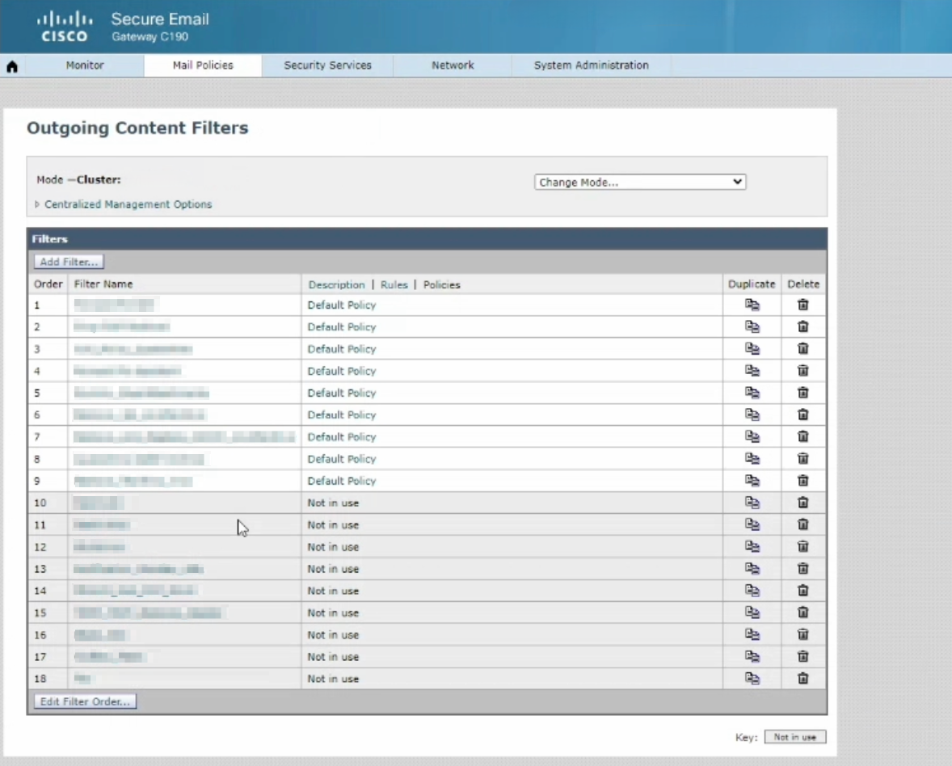

Add a New Filter
- Click Add Filter… to create a new filter.
- Set the Name of the filter to Forward-to-SpecterX.
- In the Description field, enter:
“Forwards email to the SpecterX Mail Protection Server. Once finished, the SpecterX server will return the email to Cisco SEG.”
- Set the Order value. We recommend setting this filter to the highest possible priority to ensure all emails are properly protected. However, ensure this does not interfere with other critical mail flow filters.
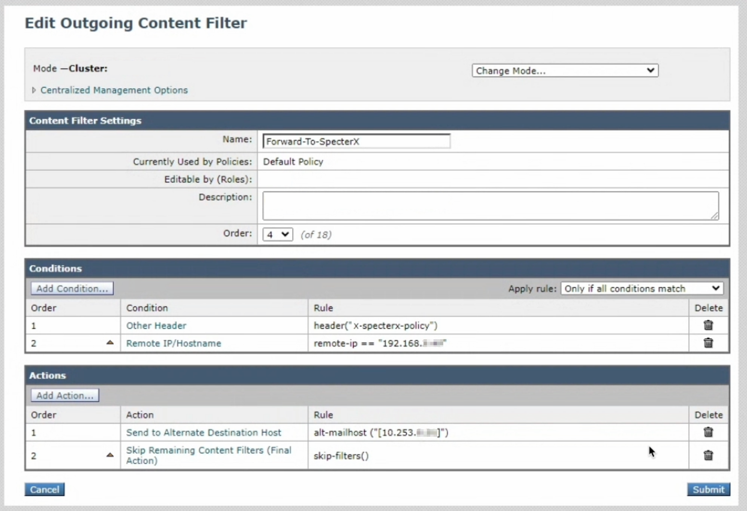

Step 3 - Define Conditions
Now, we’ll define the conditions for when this content filter will apply.

Add the First Condition
- Click Add Condition… from the content filter creation screen.
- In the side menu, select Other Header.
- Set the Header Name to: x-specterx-policy.
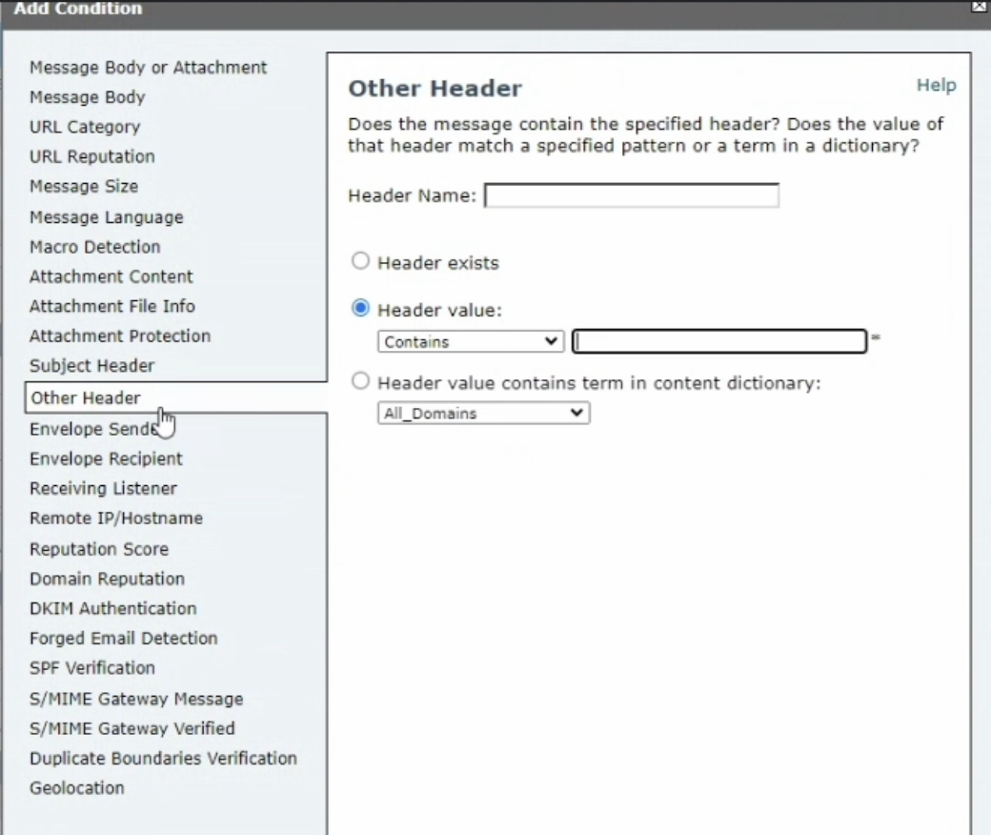

Add the Second Condition
- Click Add Condition… again.
- From the side menu, select Remote IP/Hostname.
- Set the IP address of the previous server hop in your mail flow (e.g., Exchange Server or DLP server). For example: 192.168.4.21.

Set Condition Matching Rule
- After defining your conditions, choose “Only if all conditions match” from the dropdown under the conditions section. This ensures that the rule only applies when both conditions (header and remote IP) are met.

Step 4 - Adding Actions to the Filter
We’ll configure actions to forward the email to SpecterX and ensure no further content filters are applied after that.

- Click Add Action….
- In the side menu, select Send to Alternate Destination Host.
- In the Mail Host field, enter the IP address or DNS hostname of your SpecterX Mail Protection server inside square brackets. Example: [10.251.0.11].
This will help ensure there are no loops created in the Mail Flow.
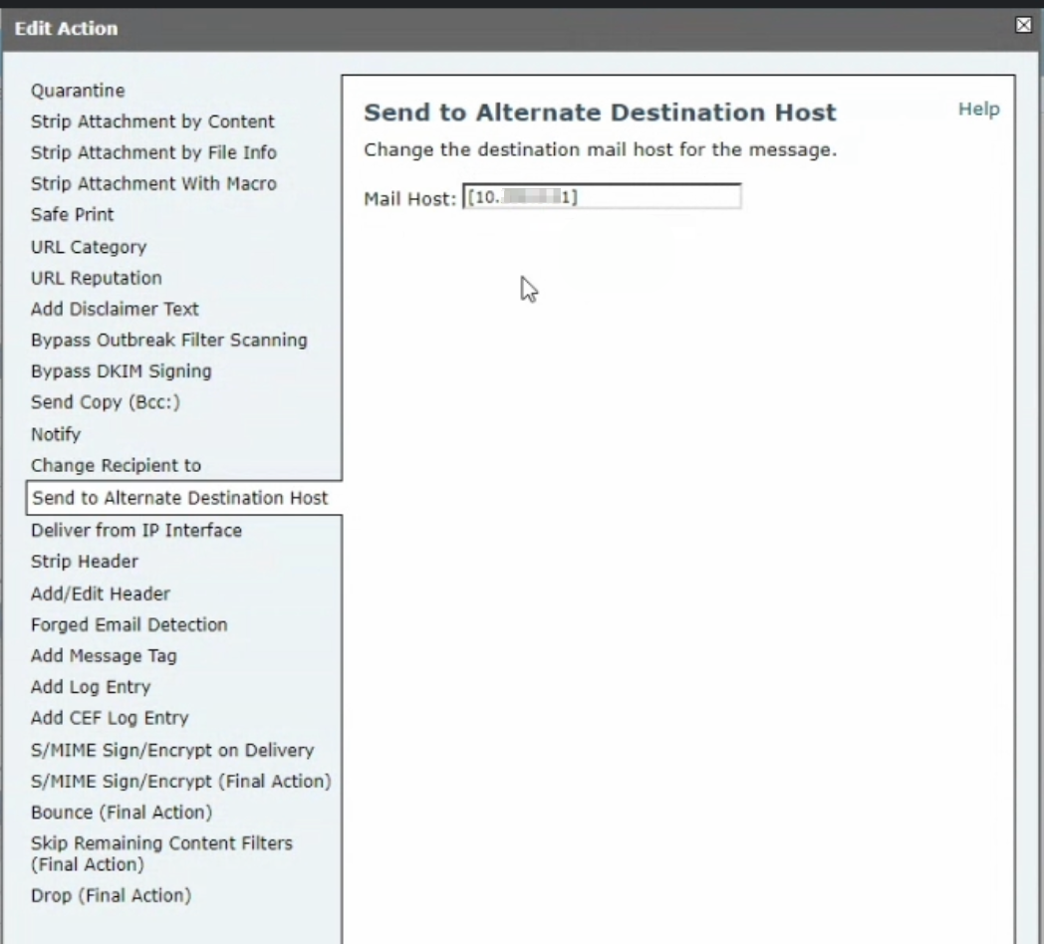

- Save and close.
- Click Add Action… again.
- In the side menu, this time select Skip Remaining Content Filters (Final Action) to ensure no further content filters are applied after forwarding to SpecterX.
- Save and close.
- The filter is now fully configured. Final result should look like this:
No

- When you’re ready to move forward, click ‘Submit’.

Step 5 - Activating the Forward-to-SpecterX Filter
Finally, we’ll assign the newly created filter to the correct outgoing mail policy.

- After configuring the filter, return to the Mail Policies menu at the top of the interface.
- Select Outgoing Mail Policies.
- Find the policy to which you want to apply the filter. This will usually be the Default Policy, or another policy with high priority in the order.
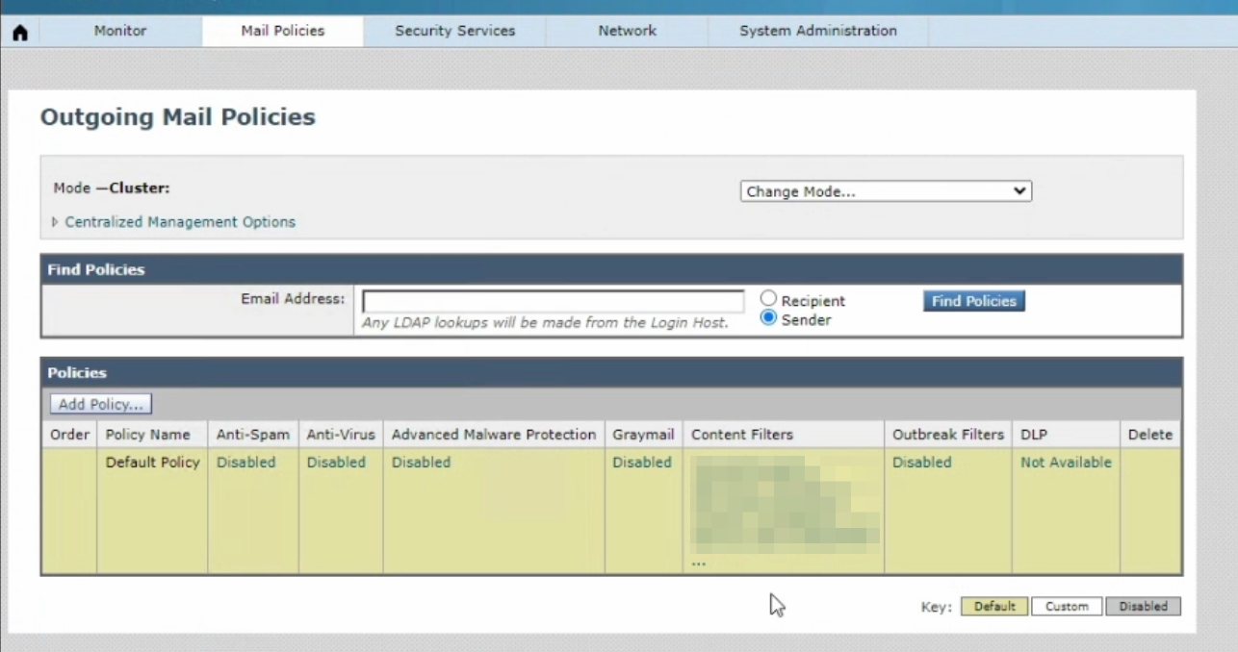

- In the policy’s row, click the clickable text in the Content Filters column.
- A window will open showing all available filters created in Cisco SEG.
- Enable the checkbox next to the Forward-to-SpecterX filter.
- After adding the filter to the desired policy, click Submit to save your changes.

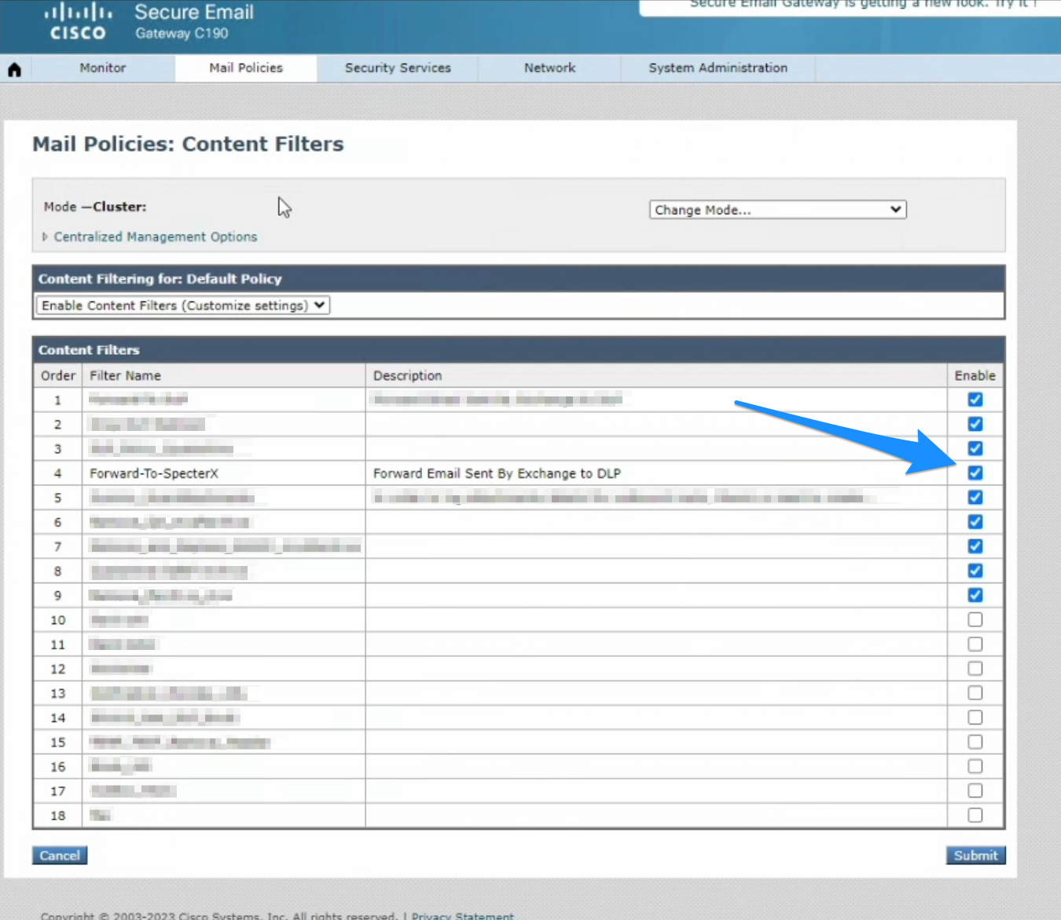

You’ve successfully configured the SpecterX Mail Protection integration with Cisco Secure Email Gateway. All your outgoing emails will now be securely forwarded to SpecterX for additional protection. Should you encounter any issues or need further assistance, feel free to reach out to our support team at support@specterx.com.

